**MOBILE APPLICATIONS LAB 5- PLAY AN AUDIO**

**NAME: LENA GEO**

**REGISTER NUMBER: 2241139**

**CODE:**

MainActivity.kt

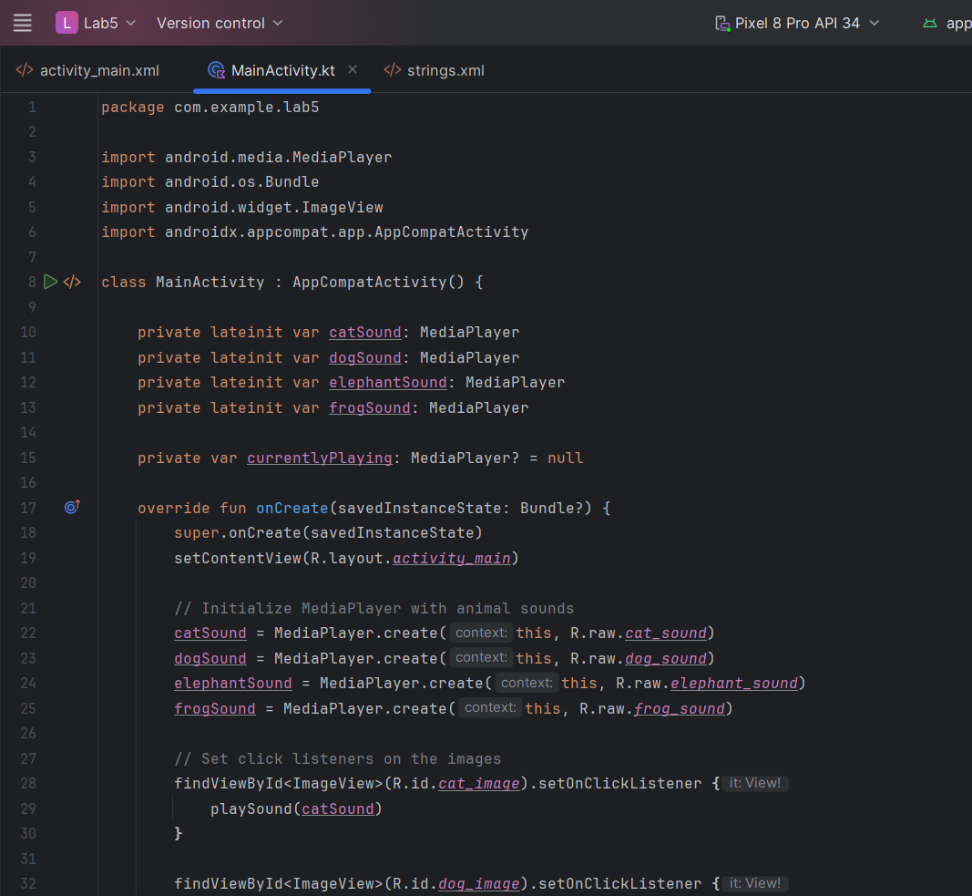

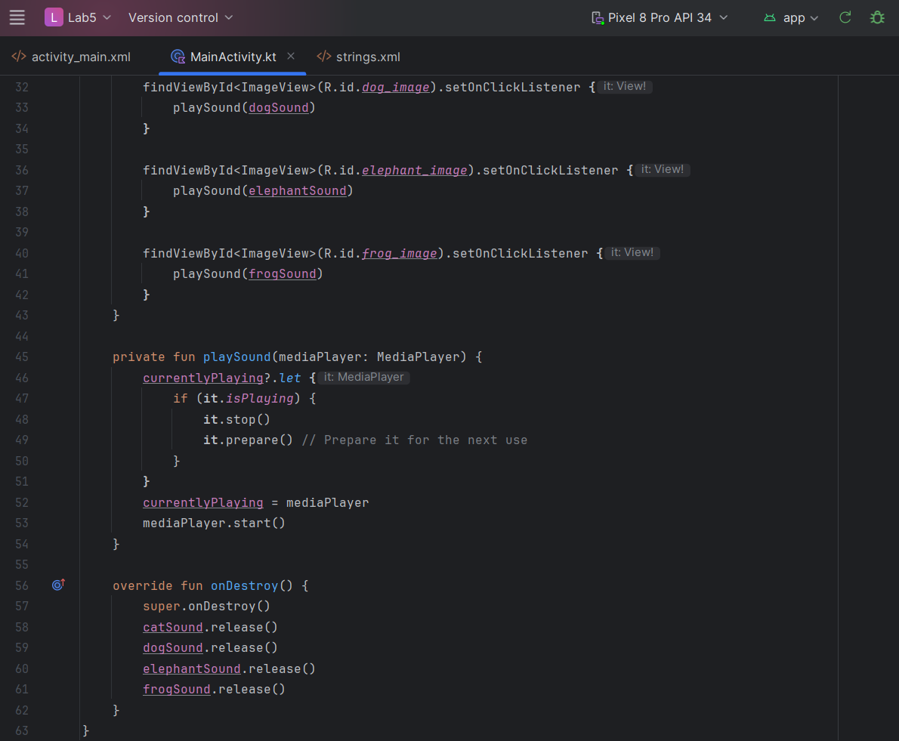

activity_main.xml

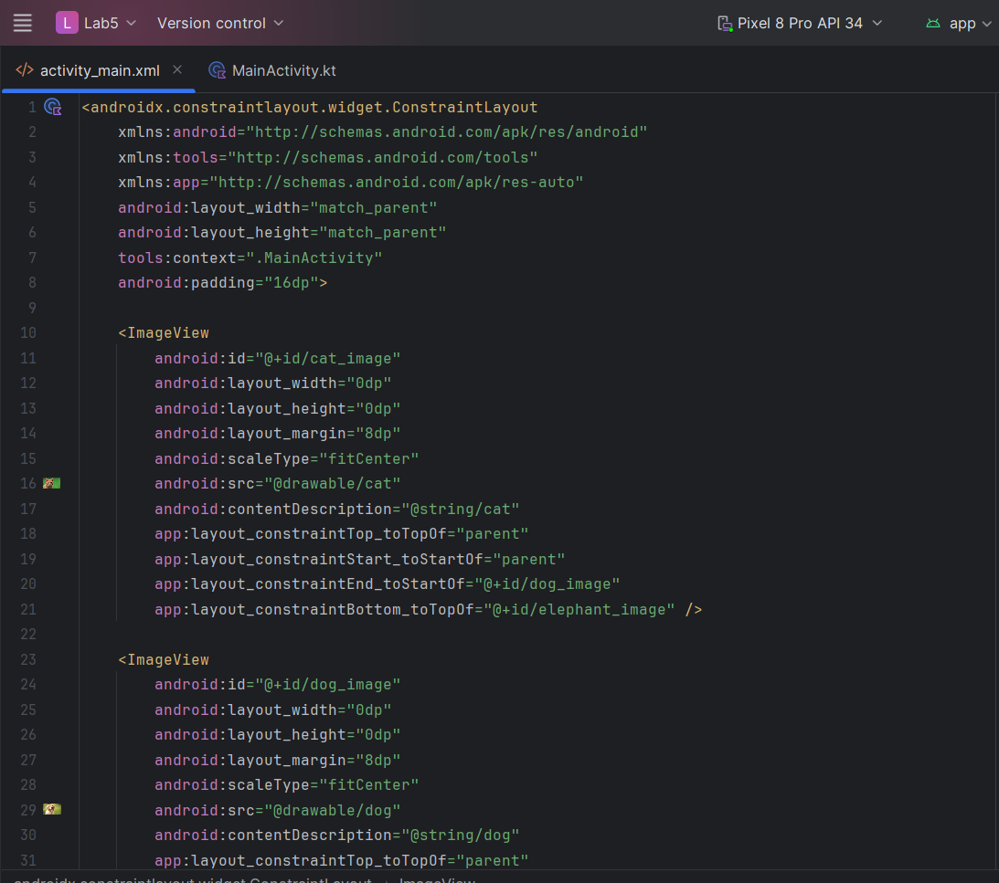

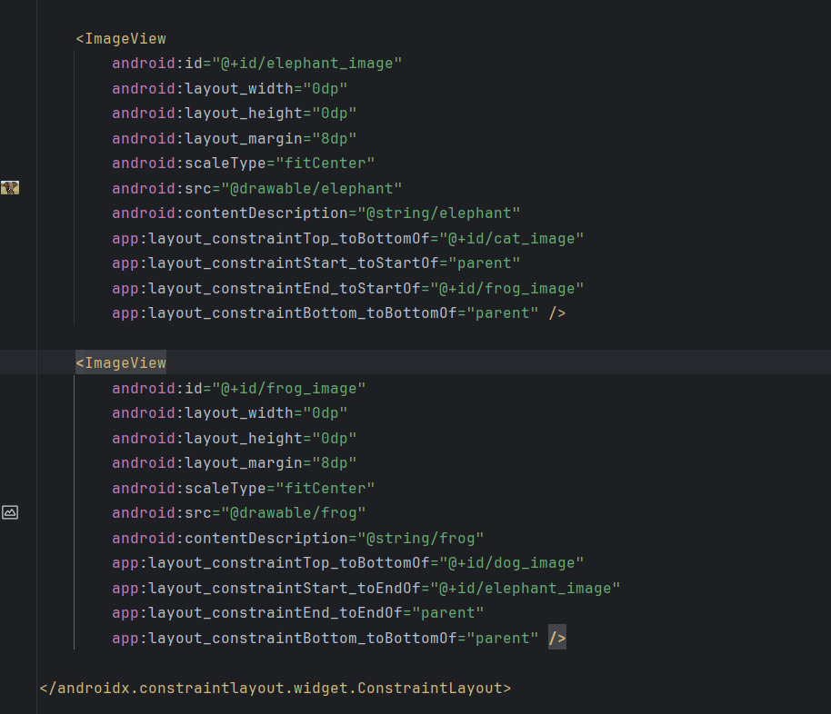

**OUTPUT:**

This Android application showcases images of four animals: a cat, dog, elephant, and frog. When a user taps on any of these images, the corresponding animal sound is played. The layout is constructed using a `ConstraintLayout` to position the images within a 2x2 grid, ensuring they fill the available space appropriately. The app utilizes the `MediaPlayer` class to handle sound playback, with each animal sound being initialized in the `onCreate` method. The `playSound` function ensures only one sound plays at a time by stopping any currently playing sound before starting the new one. This results in an interactive and user-friendly interface where tapping each image triggers a distinct animal sound, providing an engaging multimedia experience.

